The Holy Bible · King James Version
3 John
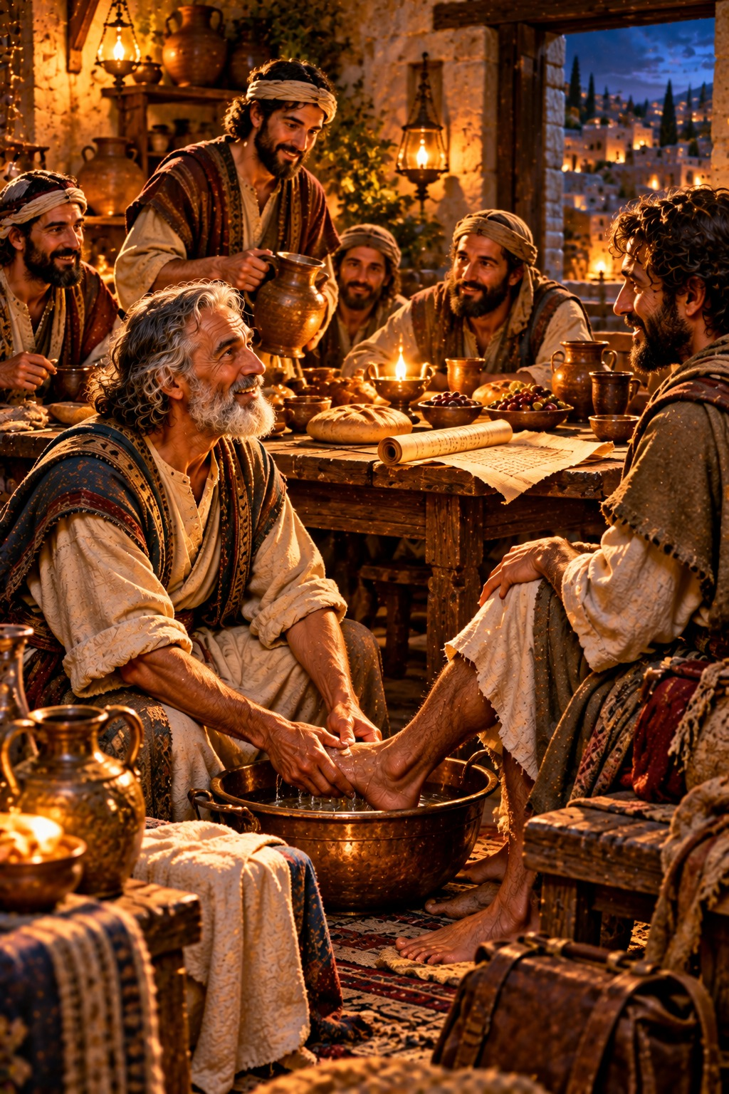
Fellowhelpers to the Truth
“We therefore ought to receive such, that we might be fellowhelpers to the truth.”
3 John 8
The Third Epistle of John · New Testament · General Epistles

Contents
3 JOHN 2
CHAPTER 1 2
Greeting to Gaius 2
Gaius Commended for Hospitality 2
Diotrephes Rebuked 2
Demetrius Commended 2
Closing Words 2

THE THIRD EPISTLE OF

3 JOHN
The third epistle of John is a personal letter from “the elder unto the wellbeloved Gaius” (verse 1), a faithful believer known for his hospitality to travelling ministers of the gospel. It was written about A.D. 90 by the chronology printed in the margins of many King James Bibles, probably from Ephesus, about the same time as the second epistle.
John commends Gaius for walking in the truth and for receiving the brethren who went forth for Christ’s name, “that we might be fellowhelpers to the truth” (verse 8). He rebukes Diotrephes, “who loveth to have the preeminence among them,” and who refused to receive John’s messengers and cast out those who did (verses 9–10). He counsels, “follow not that which is evil, but that which is good,” commends Demetrius, who “hath good report of all men,” and closes with the hope of speaking face to face (verses 11–14).

CHAPTER 1

Greeting to Gaius
T
HE elder unto the wellbeloved Gaius, whom I love in the truth.
2 Beloved, I wish above all things that thou mayest prosper and be in health, even as thy soul prospereth.
3 For I rejoiced greatly, when the brethren came and testified of the truth that is in thee, even as thou walkest in the truth.
4 I have no greater joy than to hear that my children walk in truth.

Gaius Commended for Hospitality
5 Beloved, thou doest faithfully whatsoever thou doest to the brethren, and to strangers;
6 Which have borne witness of thy charity before the church: whom if thou bring forward on their journey after a godly sort, thou shalt do well:
7 Because that for his name’s sake they went forth, taking nothing of the Gentiles.
8 We therefore ought to receive such, that we might be fellowhelpers to the truth.

Diotrephes Rebuked
9 I wrote unto the church: but Diotrephes, who loveth to have the preeminence among them, receiveth us not.
10 Wherefore, if I come, I will remember his deeds which he doeth, prating against us with malicious words: and not content therewith, neither doth he himself receive the brethren, and forbiddeth them that would, and casteth them out of the church.

Demetrius Commended
11 Beloved, follow not that which is evil, but that which is good. He that doeth good is of God: but he that doeth evil hath not seen God.
12 Demetrius hath good report of all men, and of the truth itself: yea, and we also bear record; and ye know that our record is true.

Closing Words
13 I had many things to write, but I will not with ink and pen write unto thee:
14 But I trust I shall shortly see thee, and we shall speak face to face. Peace be to thee. Our friends salute thee. Greet the friends by name.

