The Holy Bible · King James Version
2 John
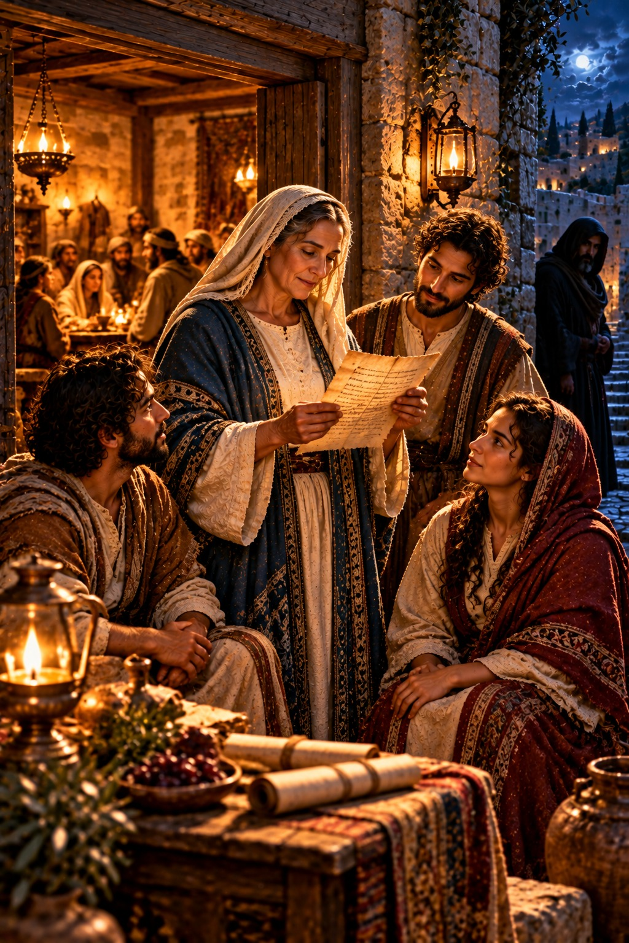
Walk in Truth and Love
“And this is love, that we walk after his commandments. This is the commandment, That, as ye have heard from the beginning, ye should walk in it.”
2 John 6
The Second Epistle of John · New Testament · General Epistles

Contents
2 JOHN 2
CHAPTER 1 2
Greeting to the Elect Lady 2
Walk in Truth and Love 2
Beware of Deceivers 2
Closing Words 2

THE SECOND EPISTLE OF

2 JOHN
In his second epistle John calls himself simply “the elder” (verse 1), a title of affection and authority in his old age. He writes “unto the elect lady and her children,” either a Christian woman and her family or, as many think, a church and its members, whom he loves “in the truth.” It was written about A.D. 90 by the chronology printed in the margins of many King James Bibles, probably from Ephesus.
This short letter joins truth and love. John rejoices that some of her children are “walking in truth,” and repeats the old commandment “that we love one another,” adding, “this is love, that we walk after his commandments” (verses 4–6). He warns against deceivers who “confess not that Jesus Christ is come in the flesh,” and counsels that such teachers should not be received or bidden God speed, lest the believers become partakers of their evil deeds (verses 7–11). He closes with the hope of coming to see them, “that our joy may be full” (verse 12).

CHAPTER 1

Greeting to the Elect Lady
T
HE elder unto the elect lady and her children, whom I love in the truth; and not I only, but also all they that have known the truth;
2 For the truth’s sake, which dwelleth in us, and shall be with us for ever.
3 Grace be with you, mercy, and peace, from God the Father, and from the Lord Jesus Christ, the Son of the Father, in truth and love.

Walk in Truth and Love
4 I rejoiced greatly that I found of thy children walking in truth, as we have received a commandment from the Father.
5 And now I beseech thee, lady, not as though I wrote a new commandment unto thee, but that which we had from the beginning, that we love one another.
6 And this is love, that we walk after his commandments. This is the commandment, That, as ye have heard from the beginning, ye should walk in it.

Beware of Deceivers
7 For many deceivers are entered into the world, who confess not that Jesus Christ is come in the flesh. This is a deceiver and an antichrist.
8 Look to yourselves, that we lose not those things which we have wrought, but that we receive a full reward.
9 Whosoever transgresseth, and abideth not in the doctrine of Christ, hath not God. He that abideth in the doctrine of Christ, he hath both the Father and the Son.
10 If there come any unto you, and bring not this doctrine, receive him not into your house, neither bid him God speed:
11 For he that biddeth him God speed is partaker of his evil deeds.

Closing Words
12 Having many things to write unto you, I would not write with paper and ink: but I trust to come unto you, and speak face to face, that our joy may be full.
13 The children of thy elect sister greet thee. Amen.

